How to Provision an IoT Server Room Monitoring Device

**IoT Monitoring Device**

How to provision IoT Server room Monitoring device

This tutorial will guide you through the process of provisioning an IoT Server Room Monitoring Device.  
  
N.B. Please do not change any other configuration other than what is specified in this document. If you have any questions please contact ben.mcbride@terex.com.

1. Start by configuring your M5 device
   1. Download M5 burner using <https://docs.m5stack.com/en/download>
   2. Ensure to select the correct version for your operating system.   
      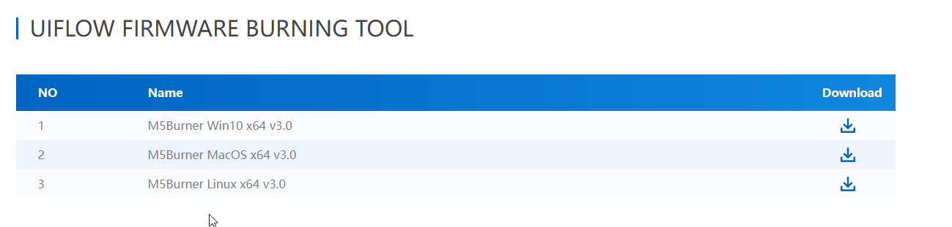
   3. Click the download button on the right side.
   4. Once this has been downloaded, unzip the file so the application can be run  
      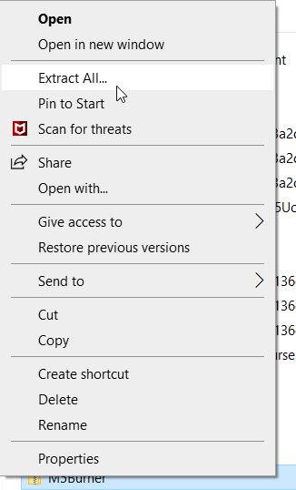
   5. Launch the M5Burner application  
      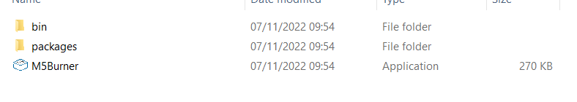
   6. Select “Download and Install this feature” on the prompt  
      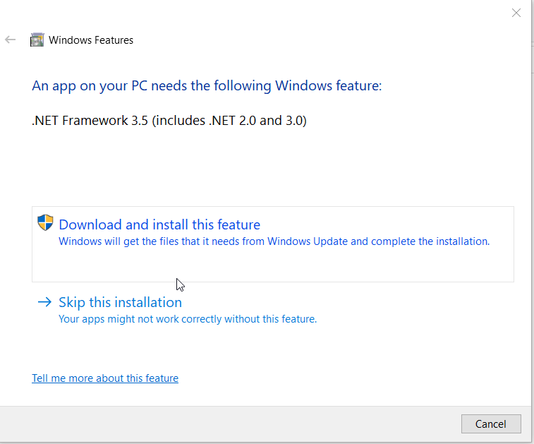
   7. Once the application has opened locate your device from the navigation bar on the left and select it  
      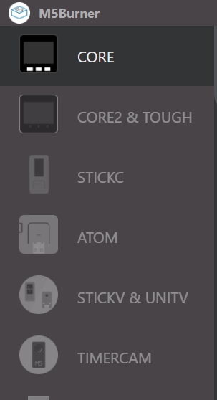
   8. Once you have located the device select the “UIFlow” device, selecting the most recent version in the drop down, then select “download”  
      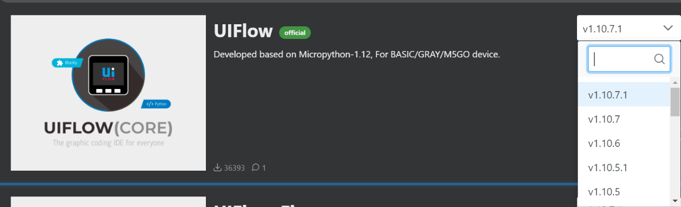  
      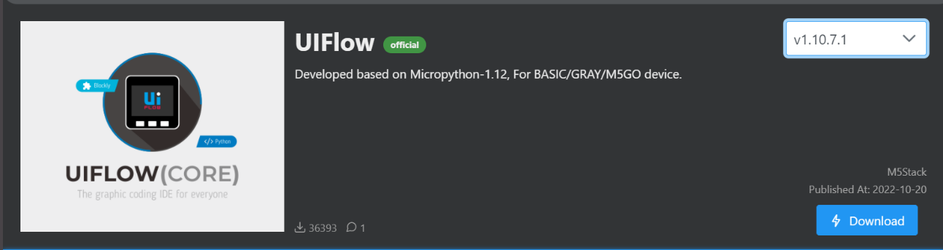
   9. The device then needs to be configured with Wi-Fi before anything else can be done. Select “Configurate”, then select the correct COM (this is random, only 1 will work). Finally select “Load”.  
      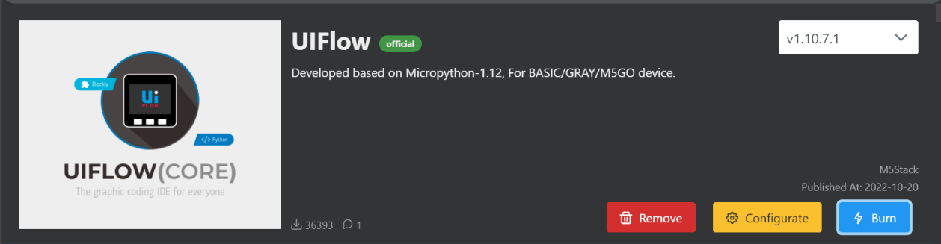  
      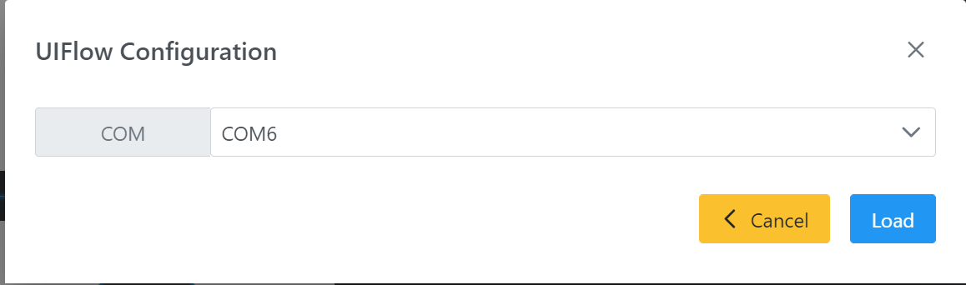
   10. Enter the WiFi SSID and WiFi Password into the correct fields, then select “Save”. Leave the rest of the options as default.  
       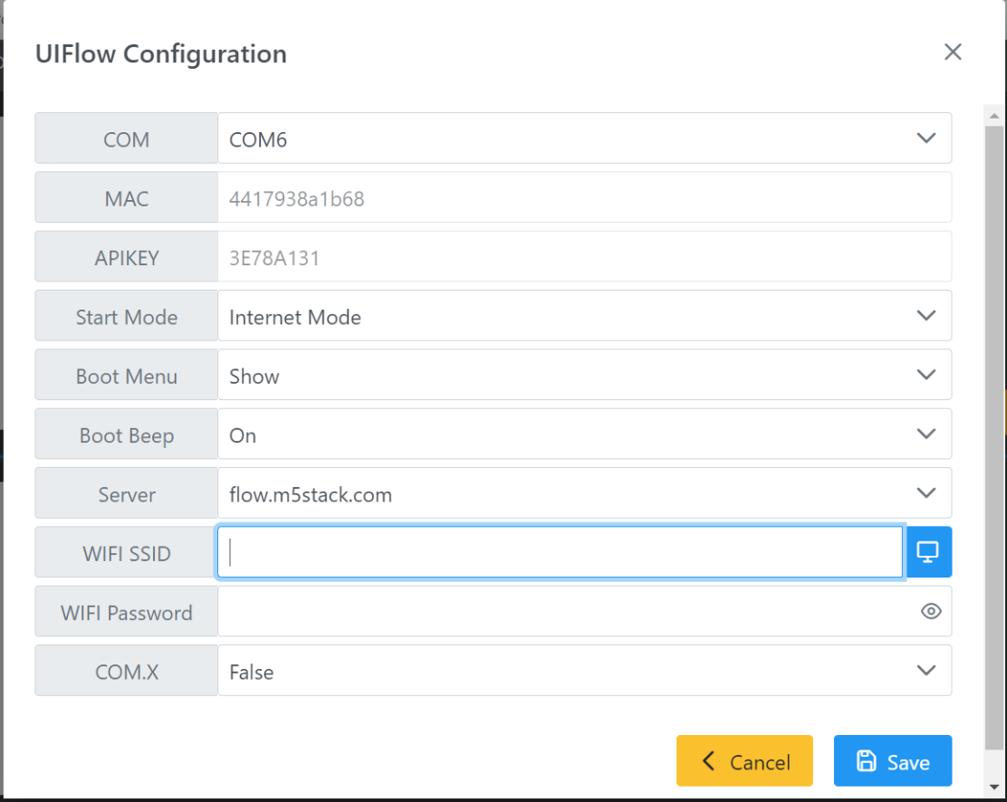
   11. This will return you to the view seen on step ‘i’. Select “Burn”, enter in the WiFi details again, select “Next”.  
       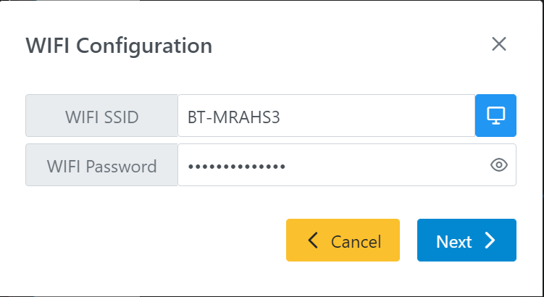
   12. Finally, select the COM used to configure the WiFi, then select “Start”.  
       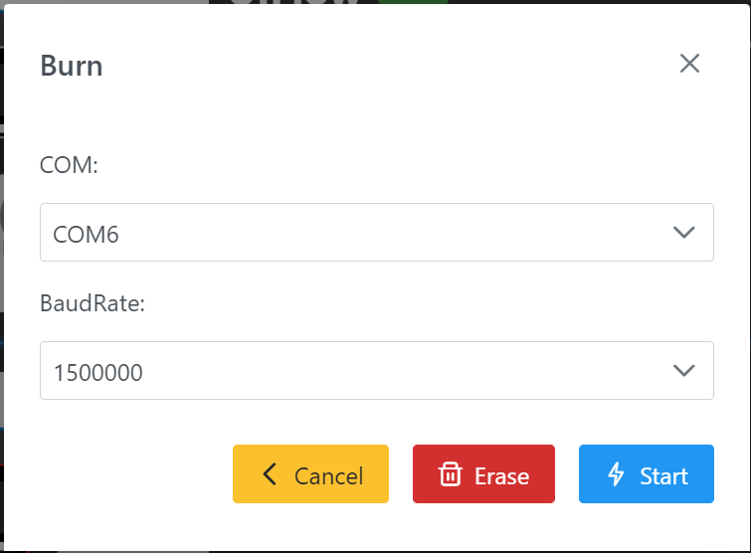
2. Create a “Thing” on IoT core
   1. Log into AWS console and select IoT Core.  
        
      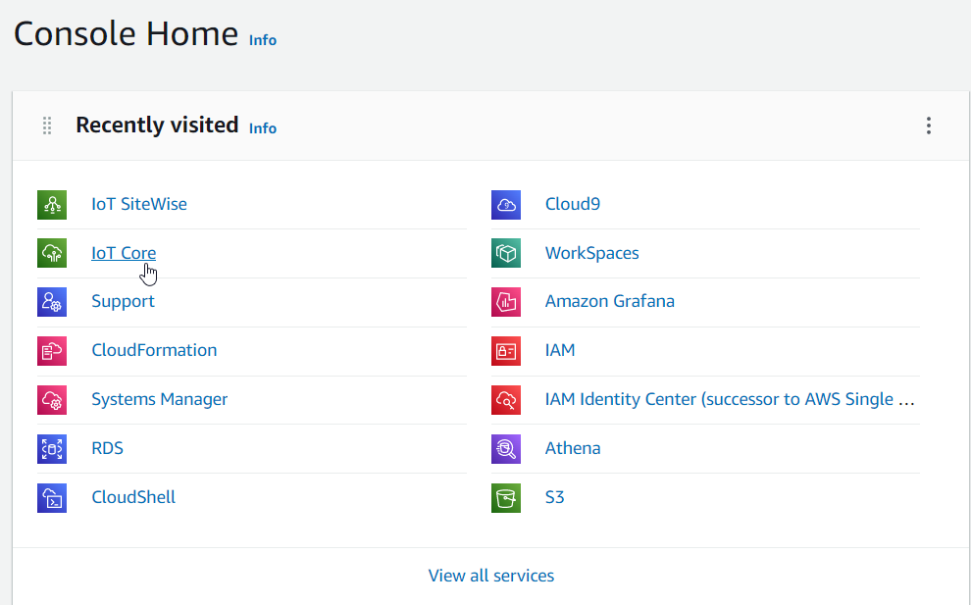
   2. Alternatively, search for IoT Core in the search bar at the top of the screen.  
      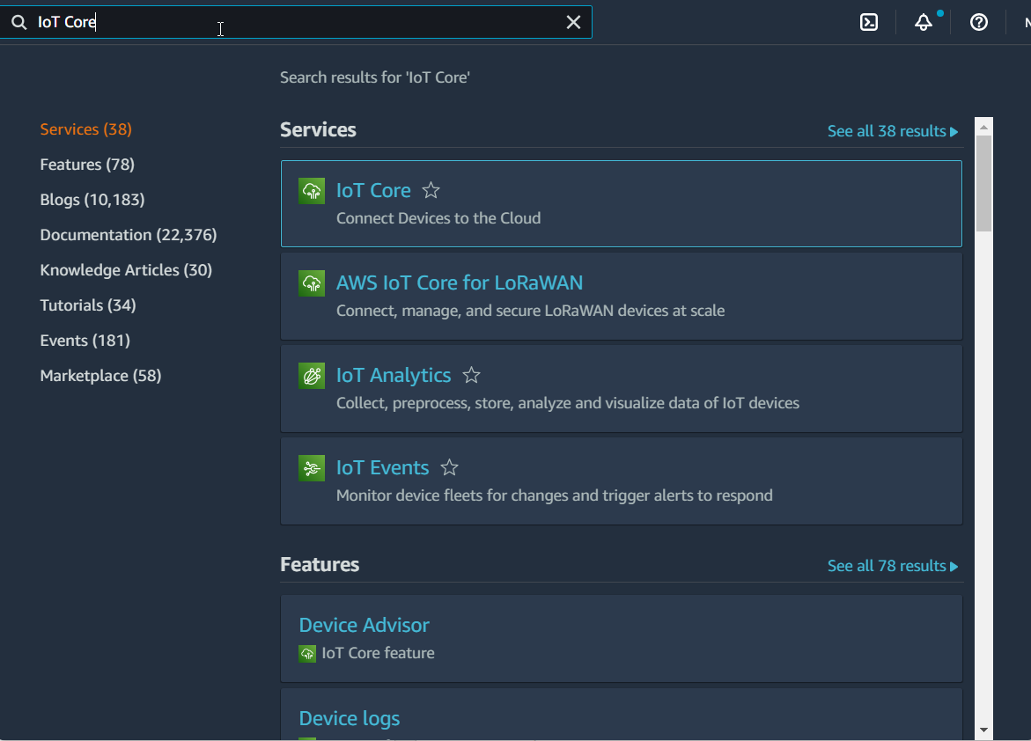
   3. Select “All devices” drop down on the left navigation bar, then select “Things”  
        
      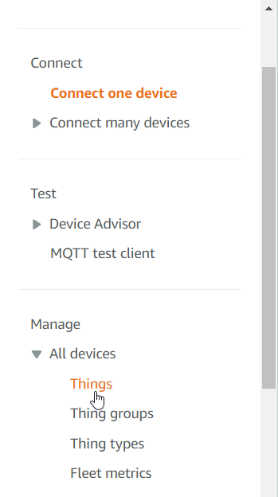
   4. Select “Create Things”  
      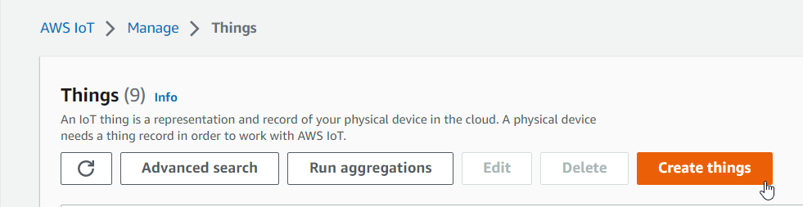
   5. Select the “Create single thing” radio button, then select “Next”.  
      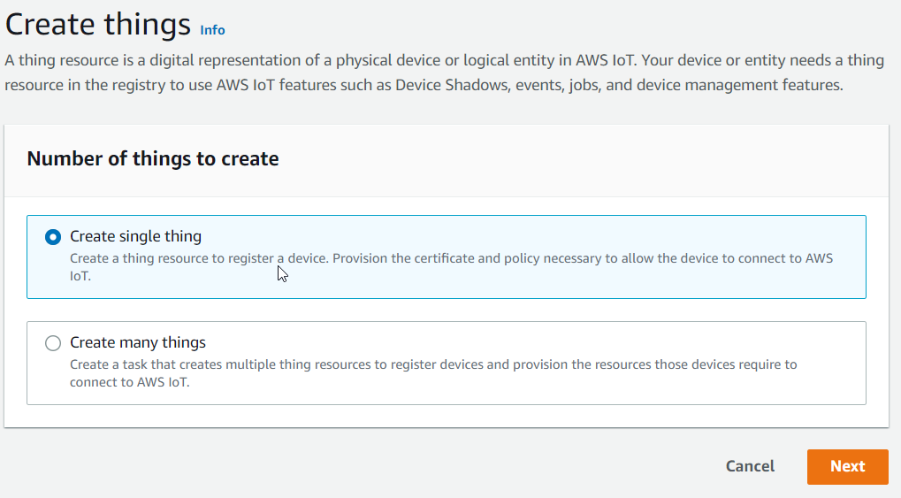
   6. Enter the name of your device (naming convention – site name abbreviation + next free number e.g Lurgan site – LUR1). Leave the rest of the options as default. The select “Next” at the bottom of the page.  
      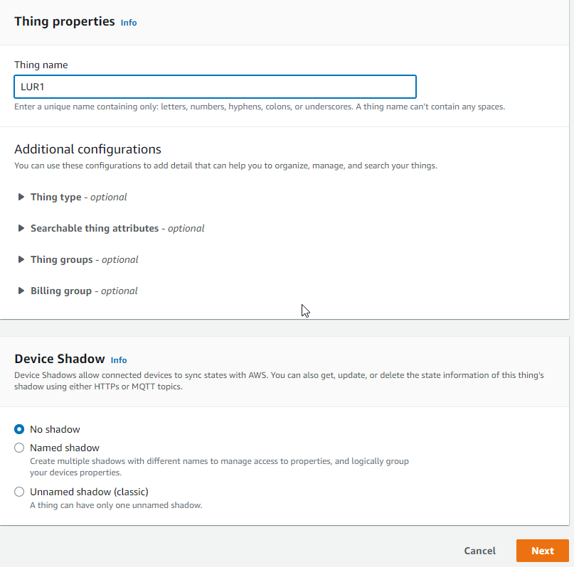
   7. Select “Auto-generate a new certificate (recommended)” radio button, then select “Next”. These certificates will be used for configuration of the device.  
      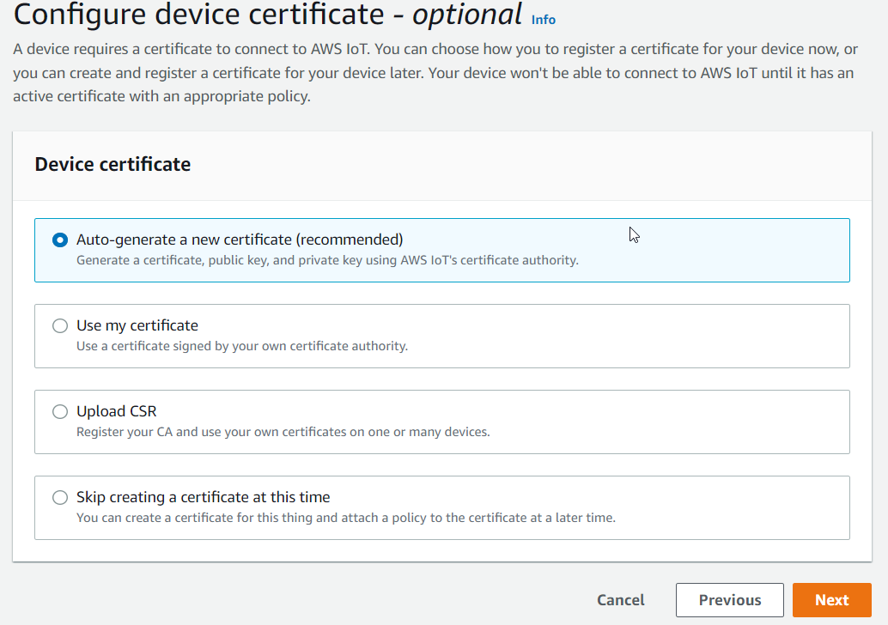
   8. Attach the “Allow_All” policy by selecting it, then select “Create thing”.  
      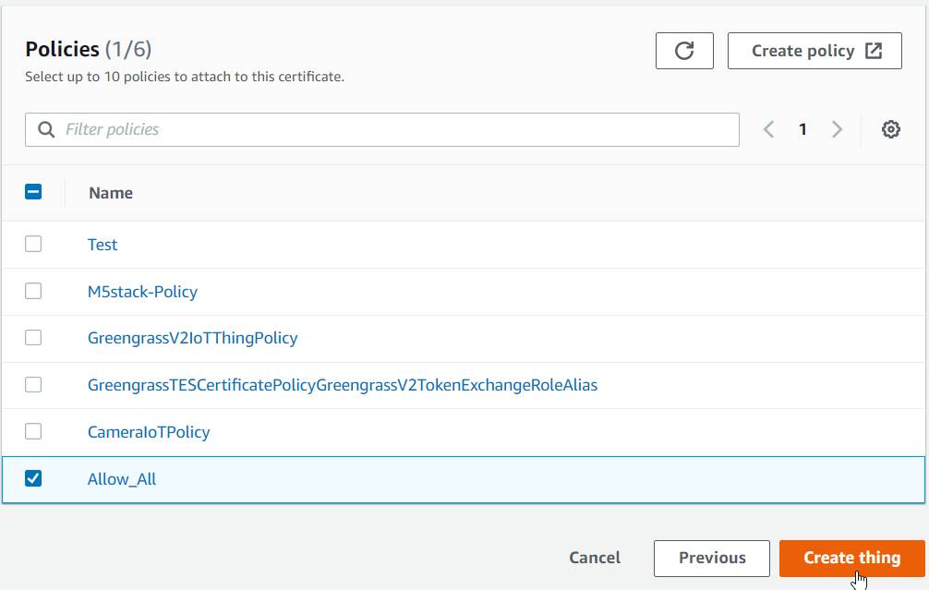
   9. Download Device certificate, public and private key file, and two end point files, and save these in a secure location (these will be needed later). Then, finally select “Done”.  
      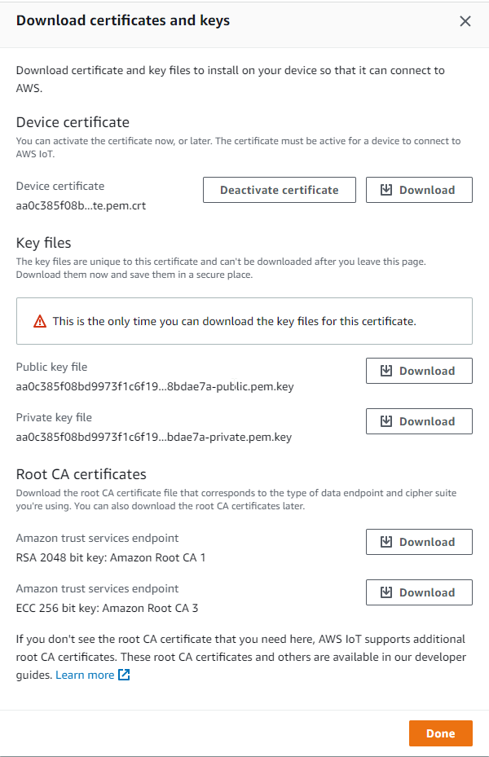
3. Configure and run the code on your IoT device
   1. To configure and run the code on the device, open the m5f file one M5flow, using <https://flow.m5stack.com/>. This is where we will launch the code from.
   2. To open the m5f file click the open folder icon at the top of the screen  
      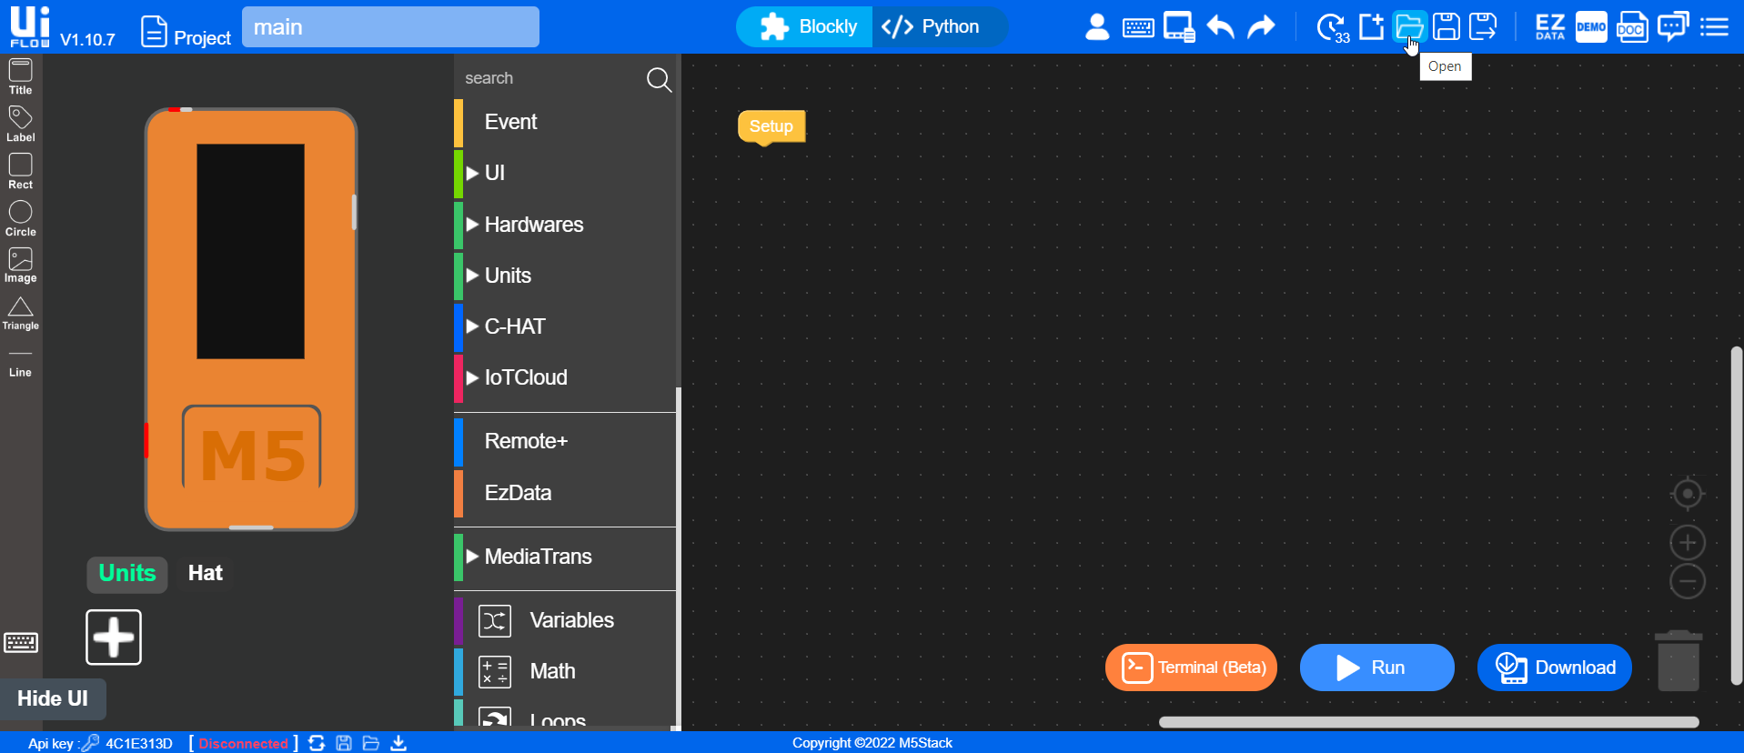
   3. Select the m5f file provided.  
      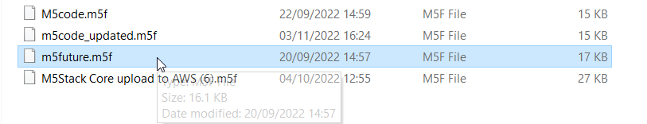
   4. Once the code has been opened on M5flow, the Api key will have to be input. This can be located on the screen of your device, and can be input into M5 code by selecting “Api key:” at the bottom left of the screen.  
      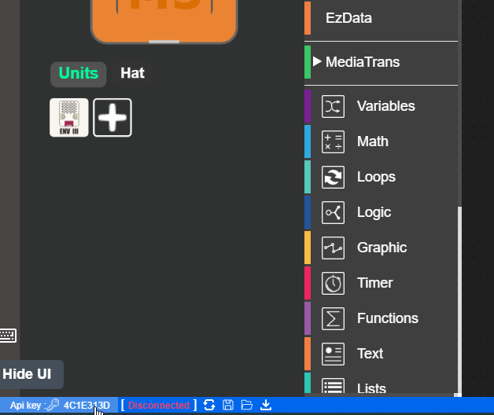
   5. Configure the Wfi name and password in the correct fields.  
      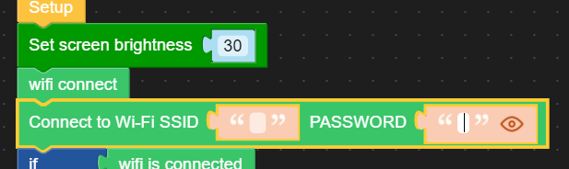
   6. Add the private key and the certificate previously downloaded to the correct fields. Add in the name of your device to “Init things name”  
      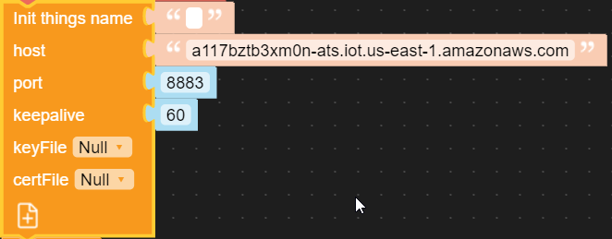
   7. Add in a Device ID to the Device ID field, this will be used to send data to IoT sitewise. Use the same name given to the device e.g LUR1.  
      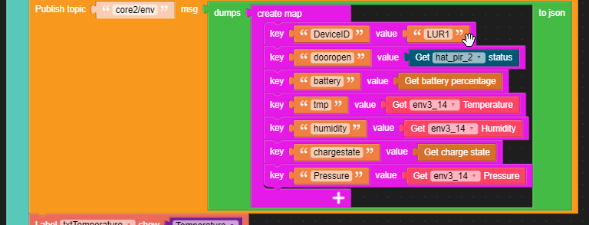
   8. Once everything has been configured, select “Run” in the bottom right corner. This will run the code on your device.  
      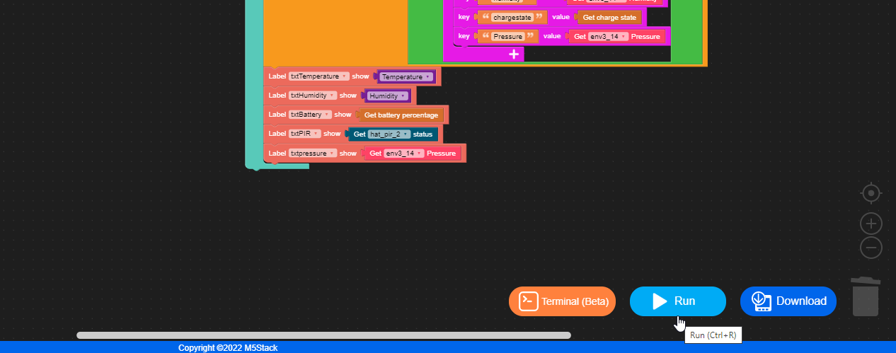
4. Create and configure an asset model in IoT SiteWise.
   1. Log into AWS console and search for IoT SiteWise in the search bar at the top.  
      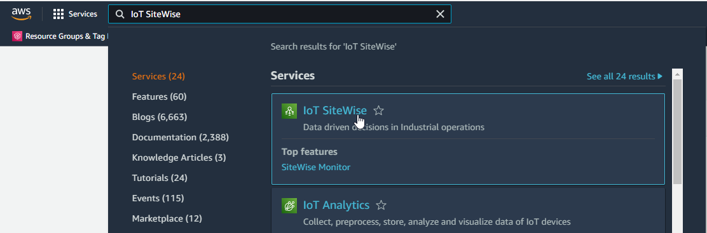
   2. Open the navigation bar on the left, and select “Build”, then “Models”  
      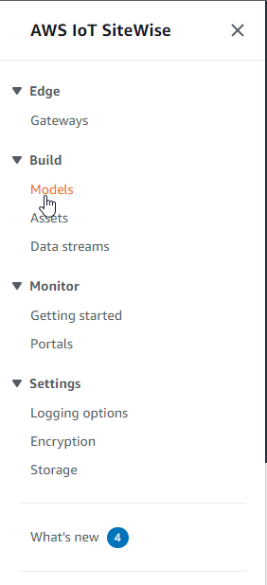
   3. Select “Create Model” at the top right of the page.  
      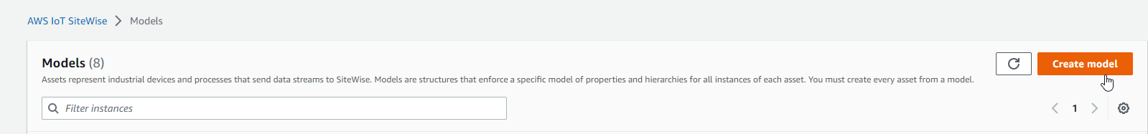
   4. Name your model the same name given to your device e.g LUR1. Add a description of “<sitename> device <number of device>” e.g. “Lurgan Device 1”.  
      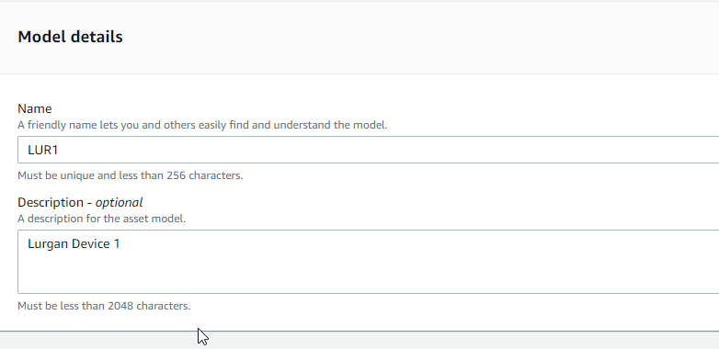
   5. Add in measurement definitions. These will be all the measurements which your device is measuring. The data type should match the measurement. The following measurements have the following data types: (Unit can stay blank – this is for the use of the user)
      1. Battery – Integer – This the percentage of charge the battery has
      2. Chargestate – String – This will return a True or False value depending on if the battery is charging or not (i.e. connected to power)
      3. Humidity – Double – This measures the moisture in the air in the server room
      4. Movement – Integer – This uses a PIR (Infrared sensor) to measure movement in the room (from this can tell if there is someone in the room). Return a 1 or 0 value.
      5. Pressure – Double – Measures air pressure within the room
      6. 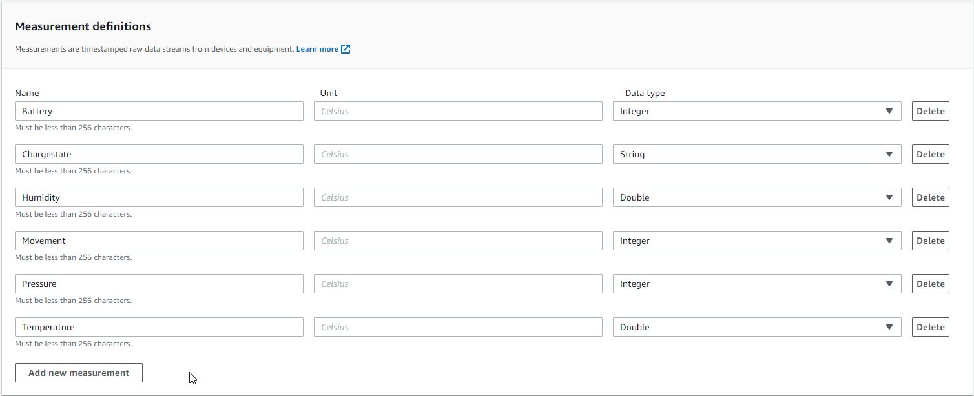Temperature – Double – This measures the temperature of the room
   6. Select “Create model” at the bottom of the page, no other configurations need to be changed/added.  
        
      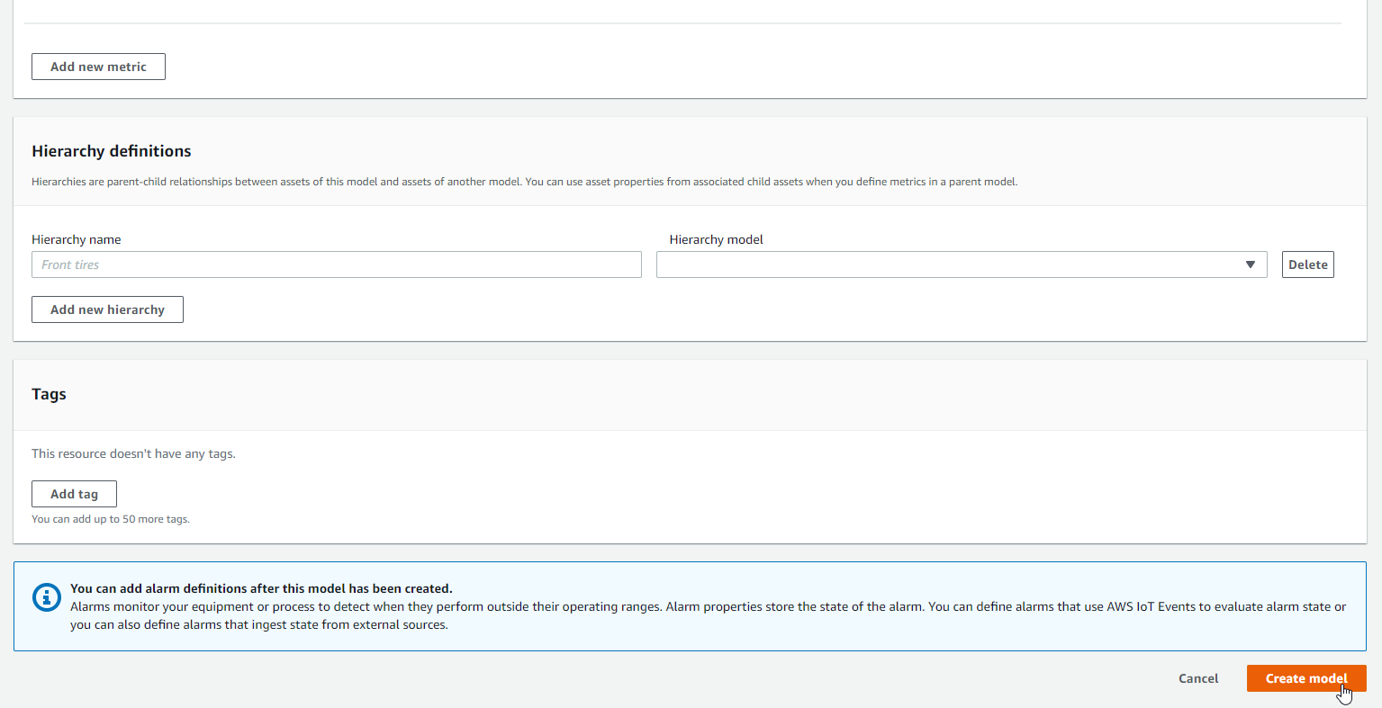
5. Create an asset in IoT sitewise.
   1. After creating your model, stay on the IoT SiteWise page and select “Assets” in the left navigation bar.  
      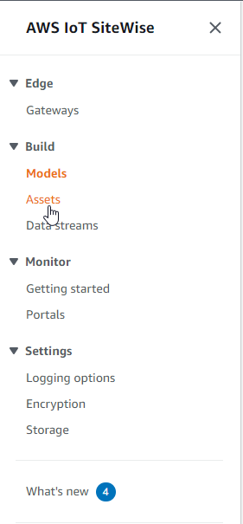
   2. Select “Create asset”  
      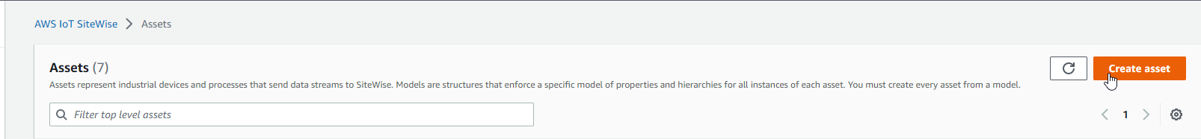
   3. Select the model previously created from the “Model” drop down.  
      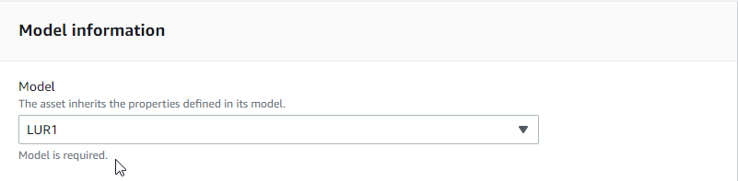
   4. Name your asset the same name as previously e.g. LUR1. The description can be the same as that of the model.  
      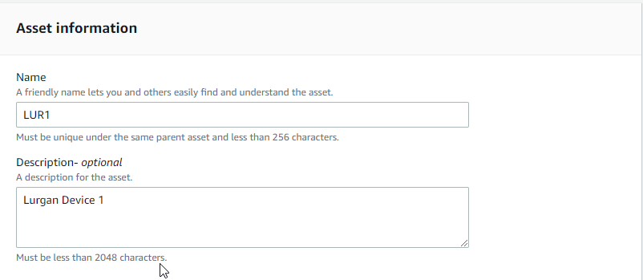
   5. Select “Create asset” at the bottom of the page.  
      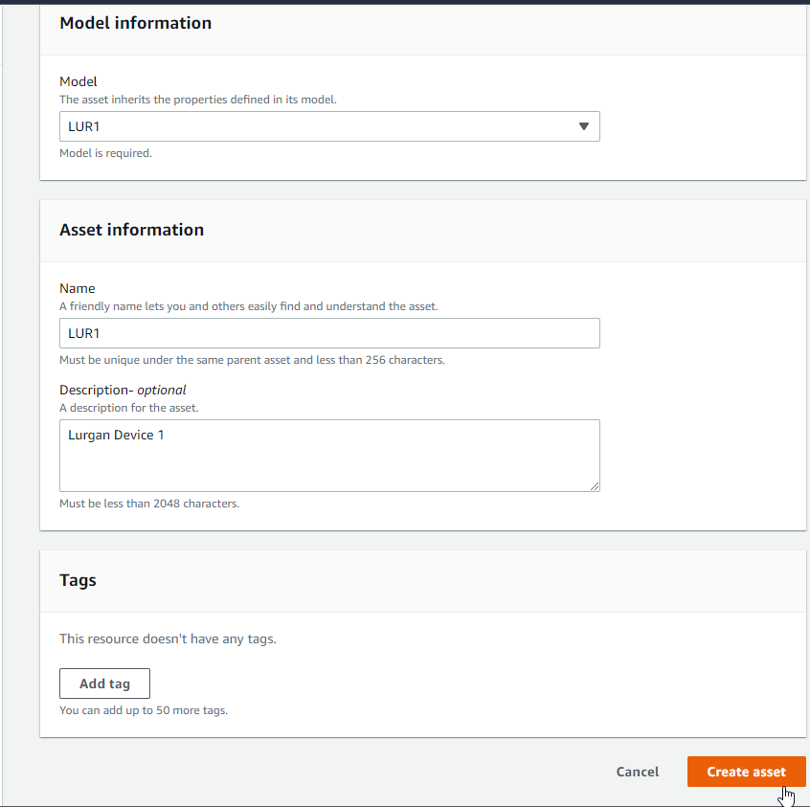
   6. Once this have been created (it may take a minute to create). Ensure you have selected the asset just created (this is normally selected by default). Once this has been selected, select “Edit”.  
      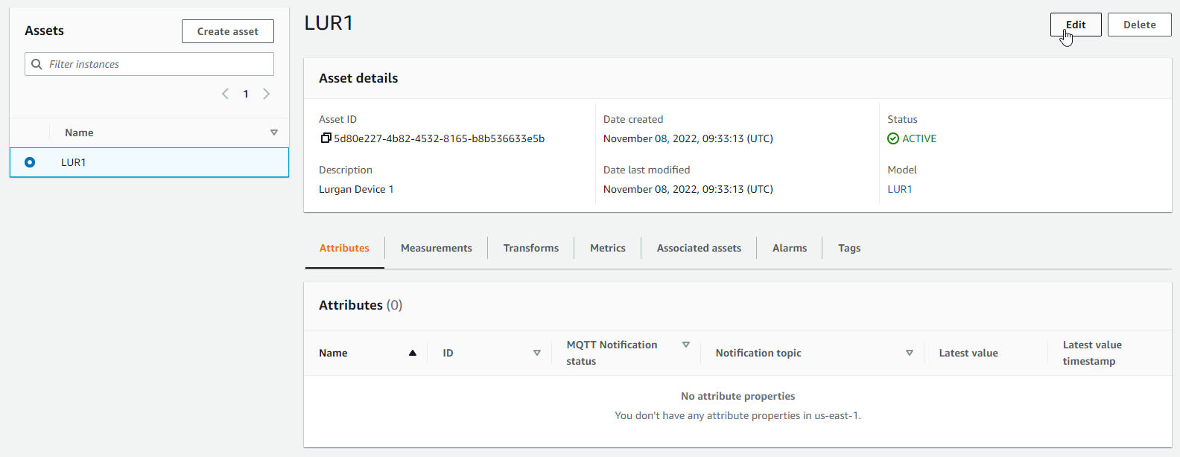
   7. On this page the property alias need to be configured within “Measurement”. The convention for this is “/site/id/<devicename e.g LUR1>/<variable name>”. (No other configuration needs to be changed/added)  
      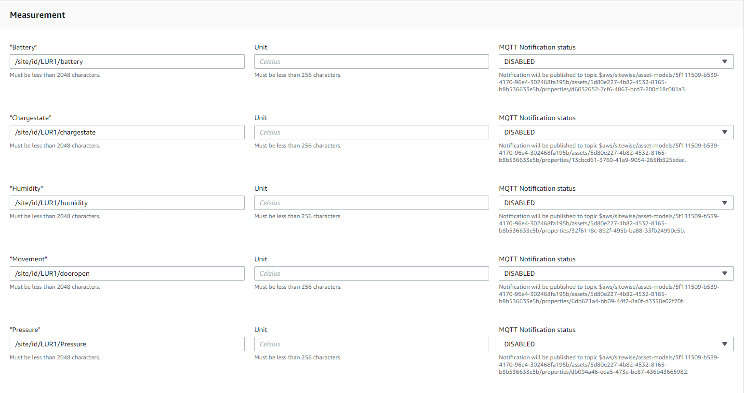
   8. Select “Save” at the bottom of the page to save the alias’  
      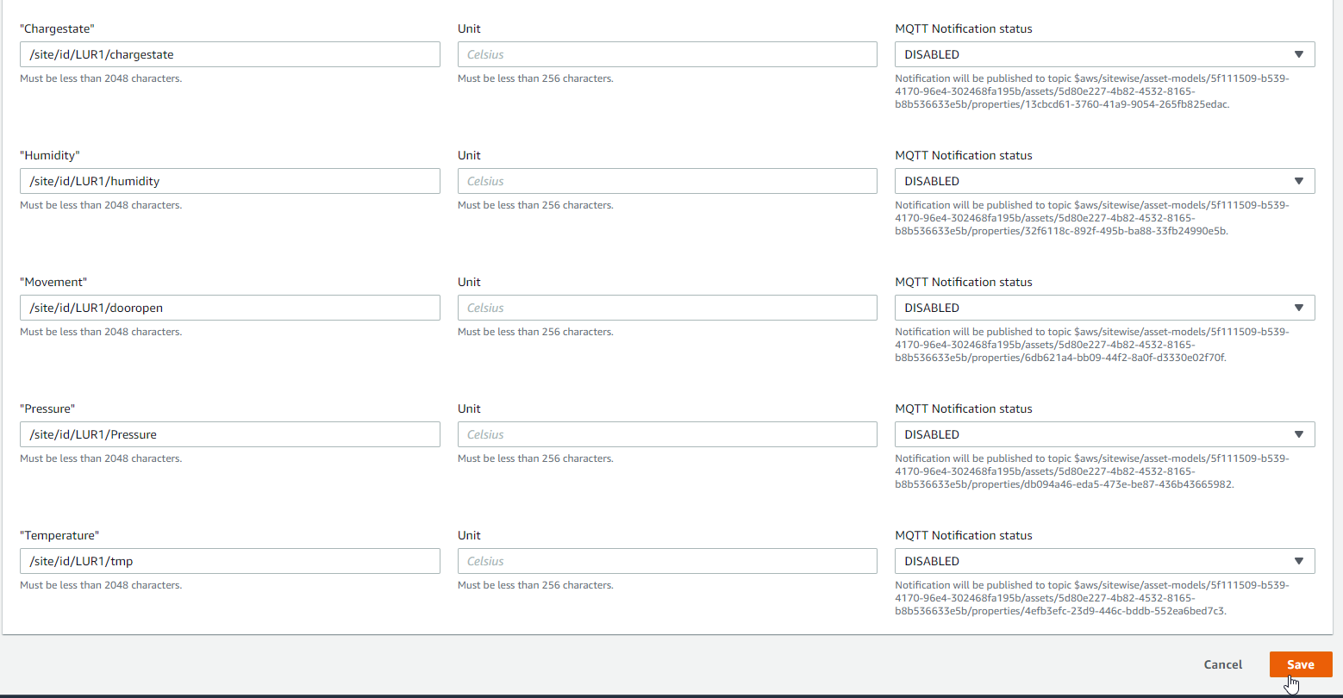
6. Configure the corresponding dashboard on Grafana.
   1. In this section only the Asset and property needs to be configured, everything else has been pre-configured so no other configurations should be changed.
   2. Select the correct dashboard using the link provided, or by logging into Grafana and searching for your dashboard. (The dashboard will be named after your site e.g. Lurgan)  
      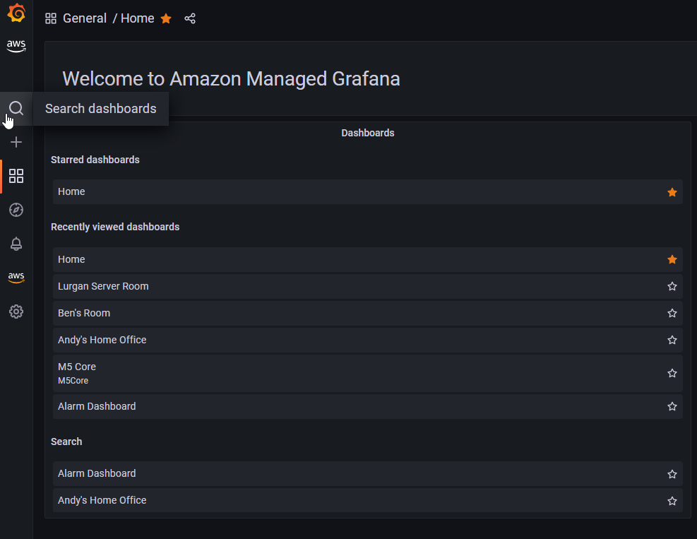
   3. After searching for your dashboard and selecting it, it will open. Start configuring your dashboard by selecting the first panel beside the name and select “Edit”.  
      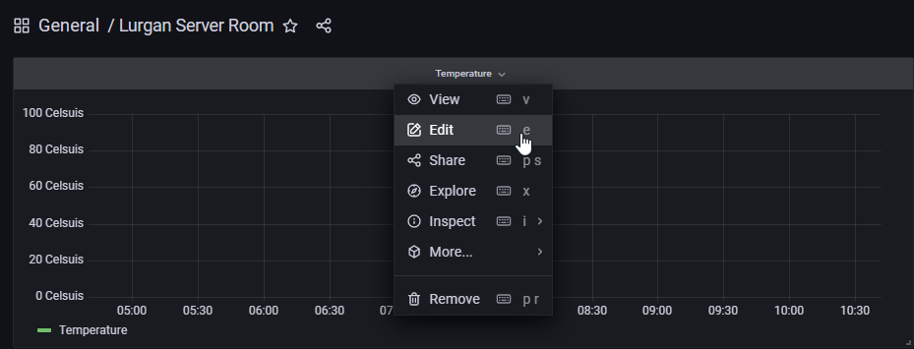
   4. Select the Query type “Get property value history”, then select the corresponding Asset e.g. LUR1, then finally select the corresponding Property for the panel, e.g. Temperature panel, choose Temperature Property etc.  
      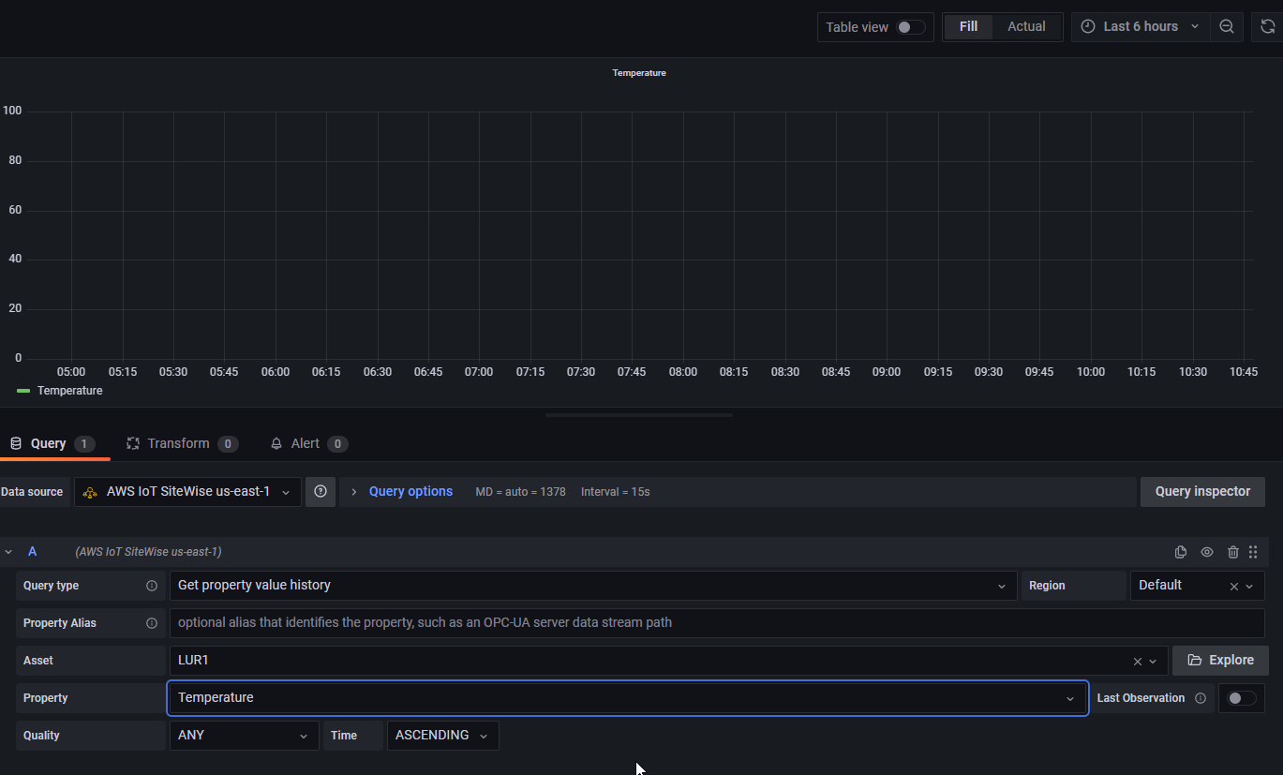
   5. Select “Apply” at the top right of the page.  
      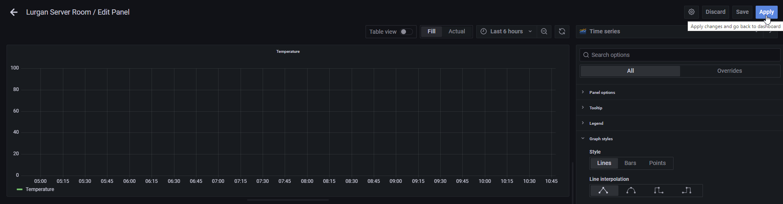
   6. Select the save dashboard icon at the top of the page to save the changes made.  
      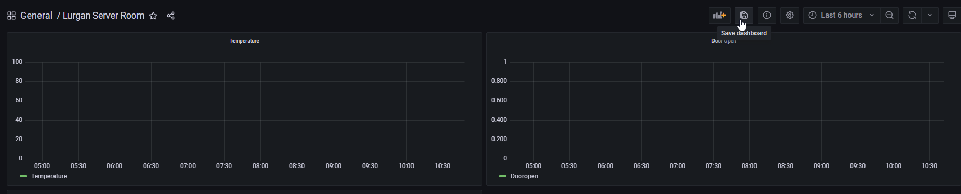
   7. Please do not change any other configuration.